LM35 Temperature Sensor

Introduction
LM35 is a temperature sensor produced by National Semiconductor. It has very high operational accuracy and a wide operating range. With small size, low cost and reliability, LM35 is widely applied in engineering. Since it uses internal compensation, the output can begin with 0℃. LM35 has many different packages. Under the normal temperature, the LM35 requires no additional calibration to reach the accuracy of plus or minus 1/4℃. The power supply mode can be classified as single power source and positive-and-negative double power supply. Its pins are as shown below.Under the positive-and-negative dual power supply mode, it can measure a negative temperature. Under the single power supply mode and 25℃, the quiescent current is about 50μA and it has a wide operation voltage range - between 4 to 20V, thus saving electricity.

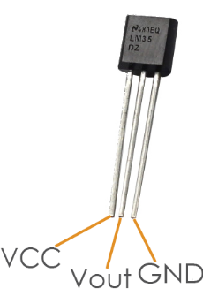

Components
- 1* KUMAN Uno board
- 1 * Breadboard
- 1 * USB data cable
- 1 * LM35 Temperature Sensor
- 1 * I2C LCD1602
- Several jumper wires

Experimental Principle
The output voltage of the LM35 is proportional to Celsius temperature. When placed in 0℃ ambient temperature, it will output 0V. The output voltage will increase 10mV every time when the temperature increases by 1℃. The calculation formula is as follows:
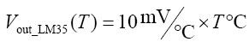

Experimental Procedures
Step 1: Build the circuit

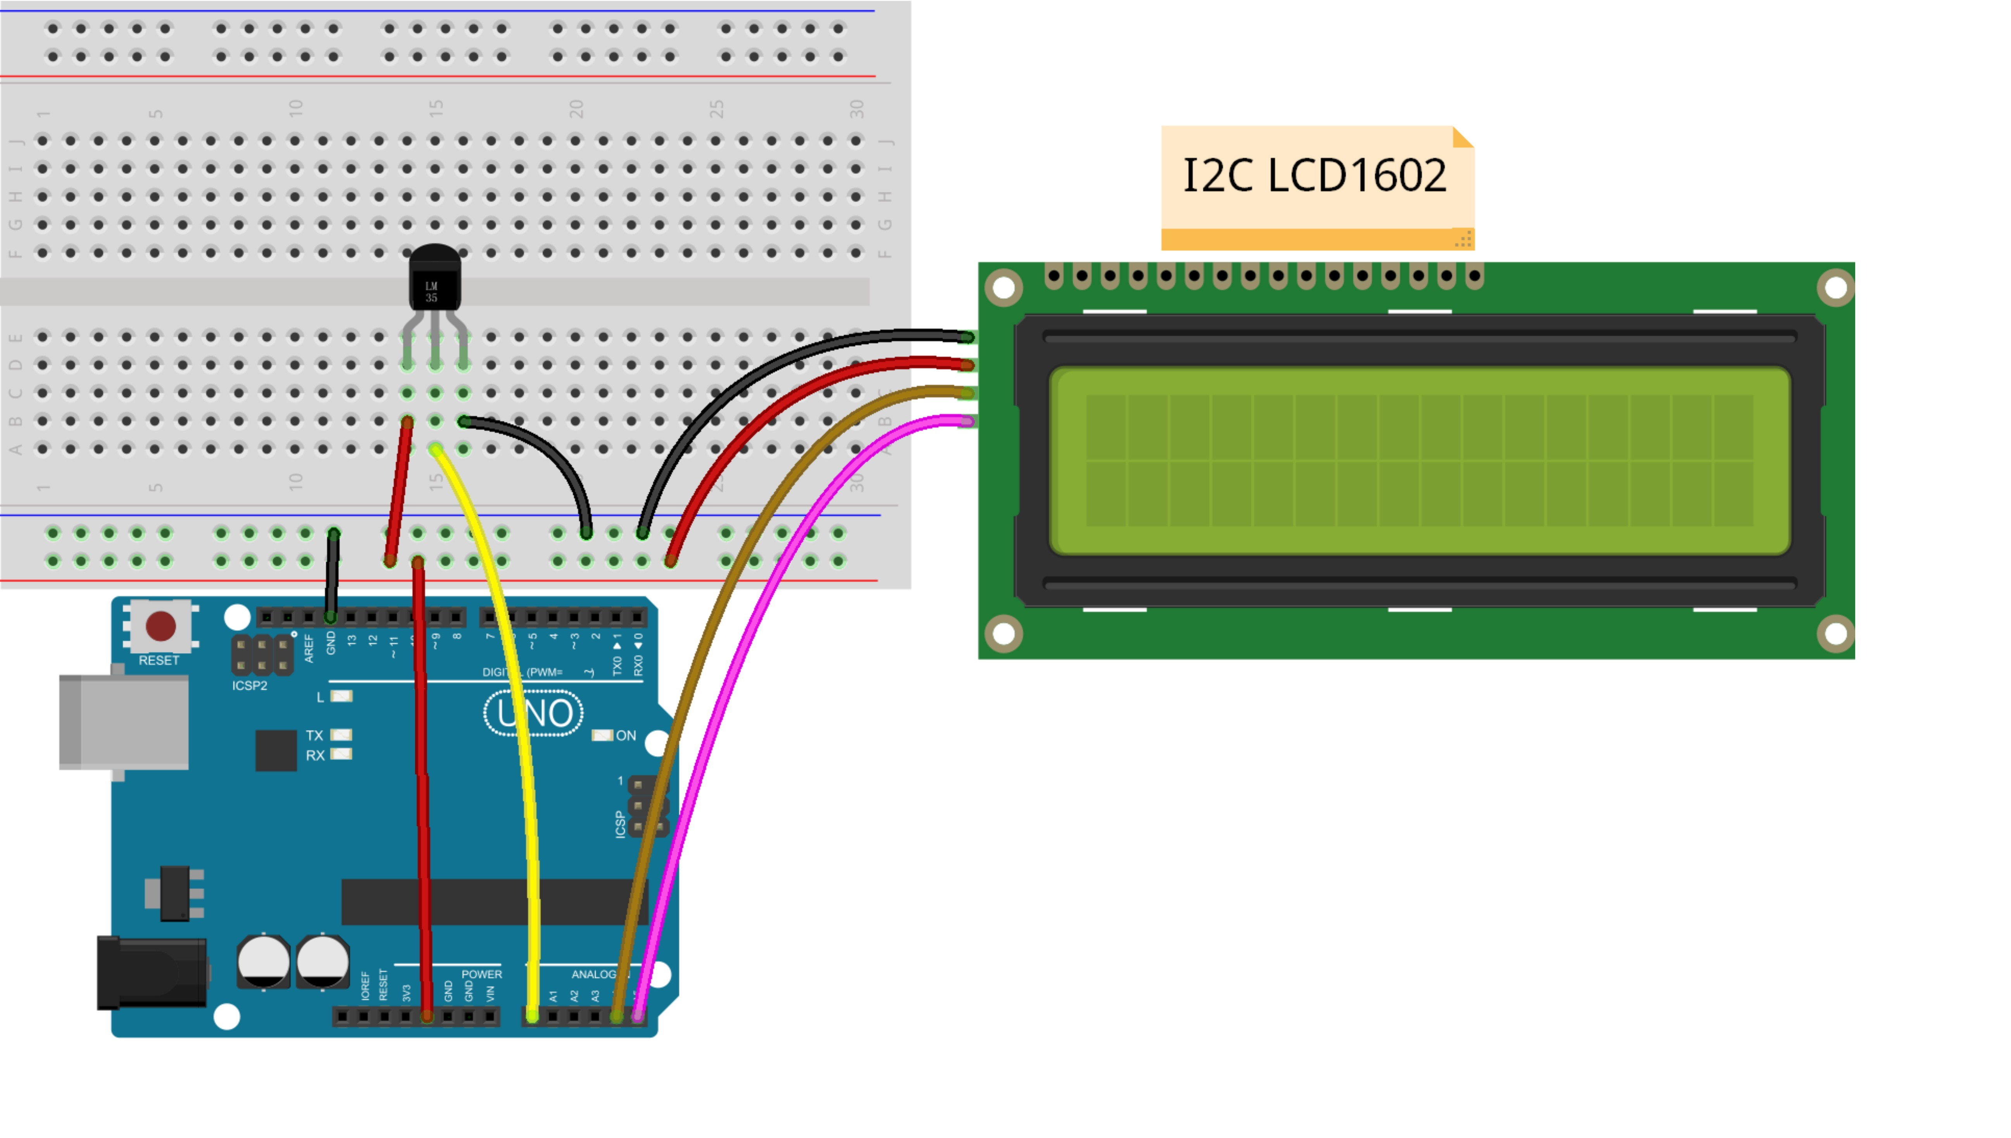
Note: Here you need to add a library. Refer to the file LiquidCrystal_I2C
Step 2: Compile the code
Step 3: Upload the sketch to the KUMAN Uno board
Now, you can see the current temperature displayed on the I2C LCD1602.

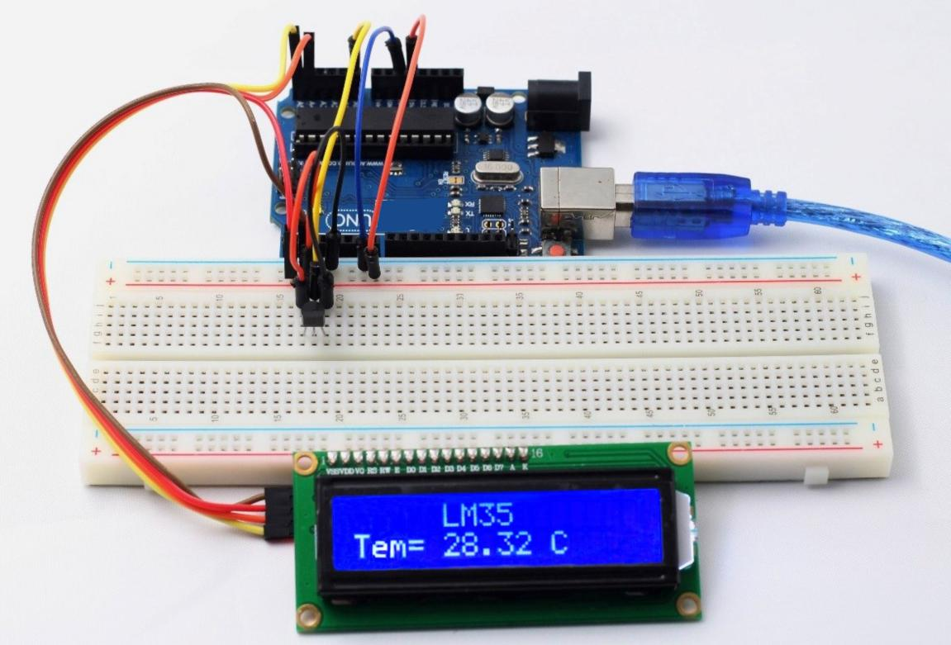

/*****************************************
* name:LM35 Temperature Sensor
* function:
* LM35 output voltage has a linear relation with the Celsius temperature, output of 0 v when 0 ℃,
* every increase 1 ℃, the output voltage increase 10 mv
*****************************************/
//lm35 attach to A0
/****************************************/
#define lmPin A0 //LM35 attach to
#include <Wire.h>
#include <LiquidCrystal_I2C.h>
LiquidCrystal_I2C lcd(0x27,16,2); // set the LCD address to 0x27 for a 16 chars and 2 line display
float tem = 0;
long lmVal = 0;
void setup()
{
lcd.init(); //initialize the lcd
lcd.backlight(); //open the backlight
}
void loop()
{
lmVal = analogRead(lmPin);//read the value of A0
tem = (lmVal * 0.0048828125 * 100);//5/1024=0.0048828125;1000/10=100
lcd.setCursor(5,0);//place the cursor on 5 column,0 row
lcd.print("LM35");//print"LM35"
lcd.setCursor(0,1);//place the cursor on 0 column,1 row
lcd.print("Tem= ");//print"Tem= "
lcd.setCursor(5,1);//place the cursor on 5 column,1 row
lcd.print(tem);//print tem
lcd.print(char(223));//print the unit" ℃ "
lcd.print("C");
delay(200);//delay 200ms
}

